**TECH BLOG**

**Prepared By –**

Durga

Rajat Khandelwal

Saurav Mehare

Vaishali

**Introduction**

Tech Blog is a blogging site where you can find a variety of technical blogs and solutions to your technical problems. The user can view the blogs written by various authors and can also raise a query about the blogs written on the site.

The admin can login to the system and view all the blogs. They can also edit an existing blog or delete a blog if required. The queries raised by the user will be directed to admin mail id and they can respond from there to it.

**Scope of Change**

Some modifications are still left in Tech Blog.

**List of impacted modules**

All the functional modules will be created from scratch.

**Process model**

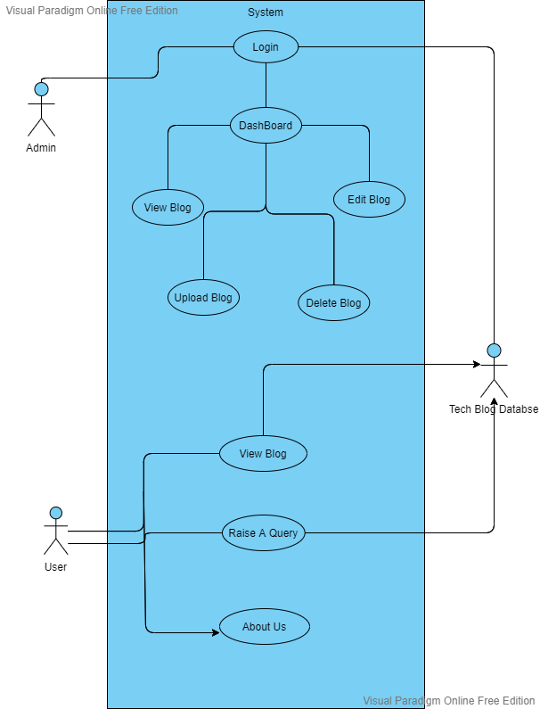

|  |  |
| --- | --- |
| Brief Description | **Login** |
| Basic Flow | This use case describes how a user log-in in to the system   1. The Admin will be given credentials to the system. 2. After the successful login, user will be taken to the appropriate landing page. 3. The following information is required to login.  * Username * Password |
| Alternate Flow | 1. The system will validate the credentials provided. If credentials are invalid, login form will be redirected again with error message. |
| Validation | 1. Valid username 2. Valid password |
| Pre-Conditions | User should have network access and Browser with latest updates. |
| Post-Conditions | Landing page has to be displayed. |

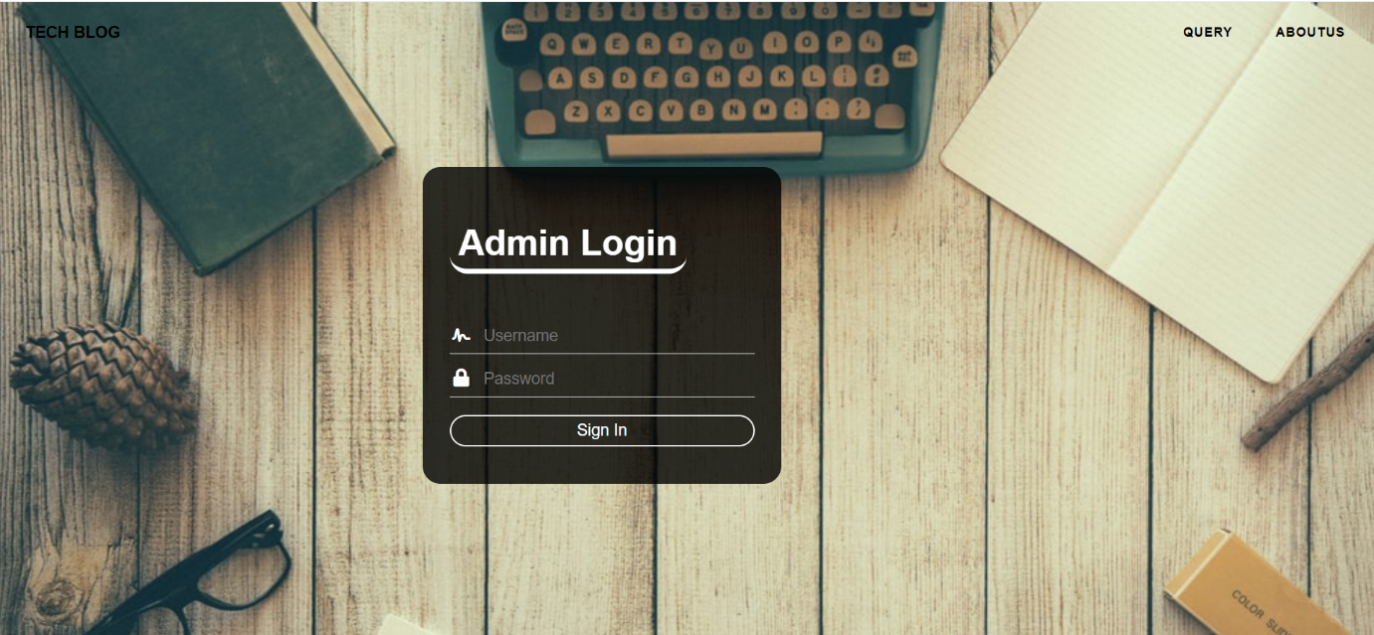

|  |  |
| --- | --- |
| Brief Description | **Dashboard** |
| Basic Flow | This use case describes how a admin would access the system   1. The Admin has to login into the system. 2. The Admin can do the following functionalities  * View all available Blogs * Edit Blog * Delete Blog * Add Blog |
| Alternate Flow | Not Available |
| Validation | Not Available |
| Pre-Conditions | User should have already logged into the system. |
| Post-Conditions | Success message should be shown. |

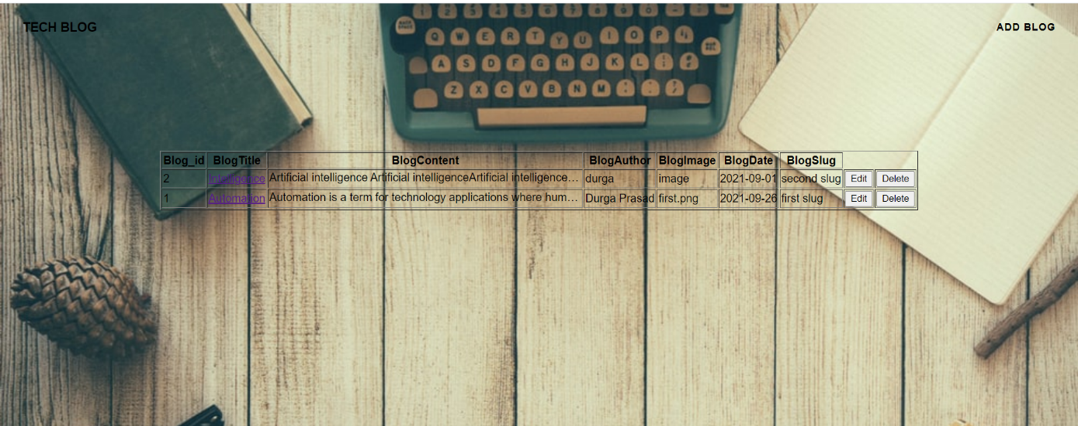

|  |  |
| --- | --- |
| Brief Description | **View Blog(Admin/Client)** |
| Basic Flow | This use case describes how a client can view the status of Blog   1. The client can access the Blog directly from Blog Homepage. 2. The following information would be displayed on every Blog.  * Blog Title * Blog Author * Blog Publish Date |
| Alternate Flow | Not Applicable |
| Validation | Not Applicable |
| Pre-Conditions | Not Applicable |
| Post-Conditions | Not Applicable |

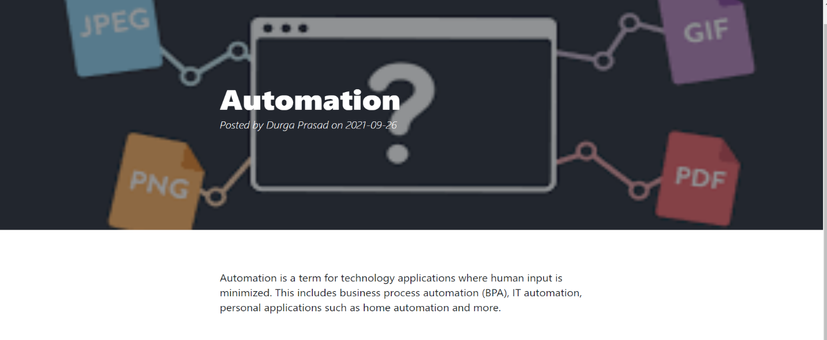

|  |  |
| --- | --- |
| Brief Description | **Add Blog** |
| Basic Flow | This use case describes how a admin would add blog.  1.Admin should be logged in to add blog.  2.The following information is required to login.   * Blog ID * Blog title * Blog Content * Blog author * Blog image * Blog Date * Blog slug |
| Alternate Flow | System will validate, if entered id is not unique /image path will not correct then blog will not successfully added. |
| Validation | Not Applicable |
| Pre-Conditions | User should have network access and Browser with latest updates. |
| Post-Conditions | Success message should be shown.(Blog Added Successfully) |

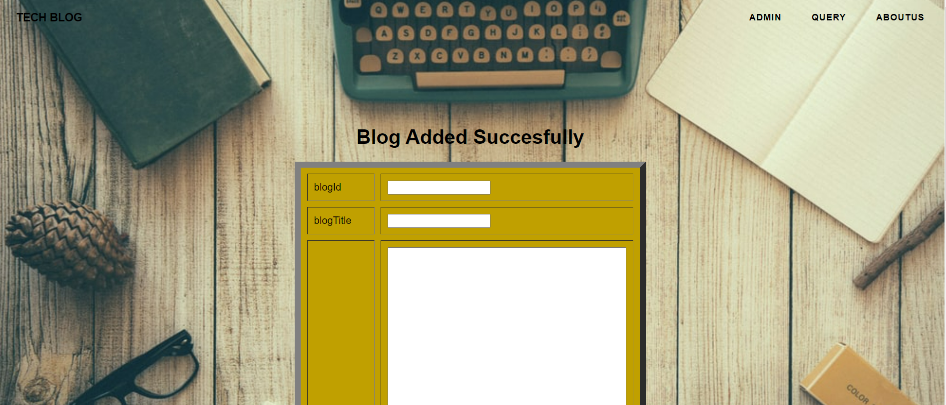

|  |  |
| --- | --- |
| Brief Description | **Delete Blog** |
| Basic Flow | This use case describes how a admin would delete blog.  1. Admin should be logged in to delete blog.  2. Through dashboard admin can directly delete the blog by click on delete button |
| Alternate Flow | Not Applicable |
| Validation | Not Applicable |
| Pre-Conditions | User should have network access and Browser with latest updates. |
| Post-Conditions | Success message should be shown.(Blog Deleted Successfully) |

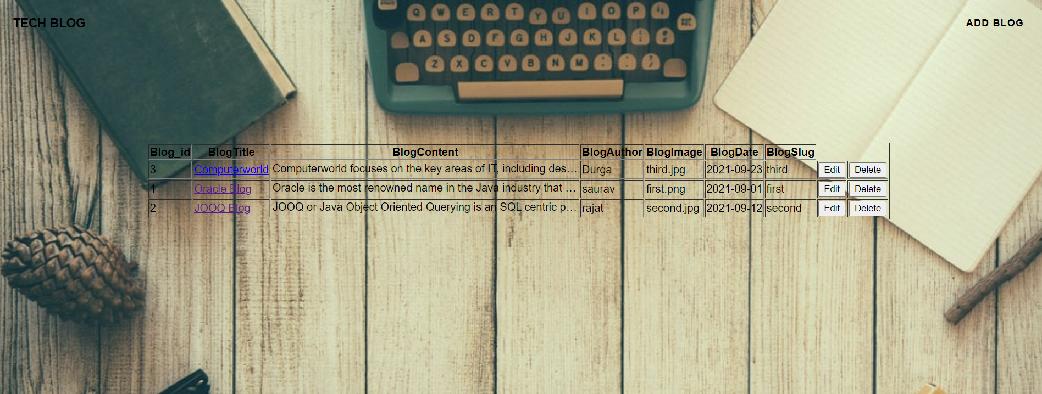

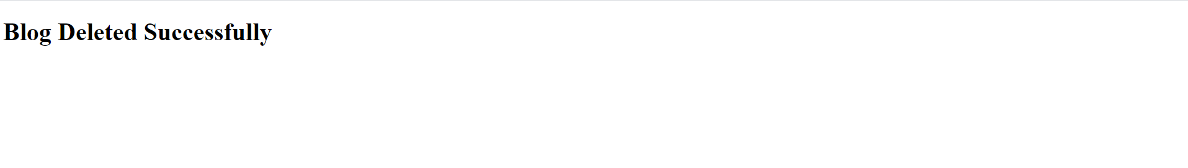

|  |  |
| --- | --- |
| Brief Description | **Edit Blog** |
| Basic Flow | This use case describes how a admin would edit blog.  1. Admin should be logged in to edit blog.  2. Through dashboard admin can directly edit the blog by click on edit button |
| Alternate Flow | Not Applicable |
| Validation | Not Applicable |
| Pre-Conditions | User should have network access and Browser with latest updates. |
| Post-Conditions | Success message should be shown.(Blog Updated Successfully) |

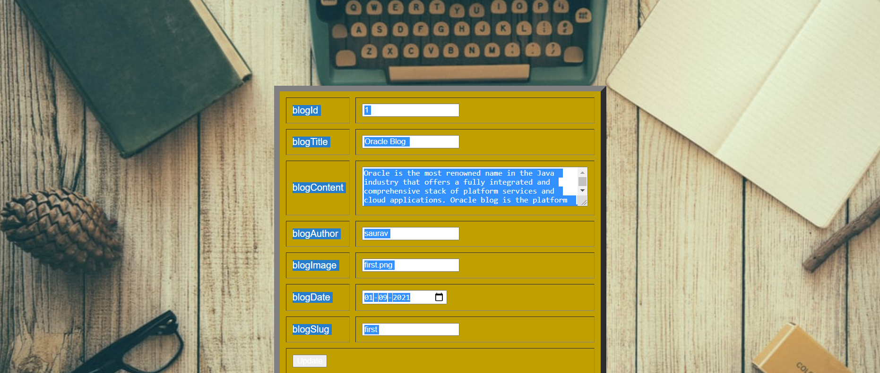

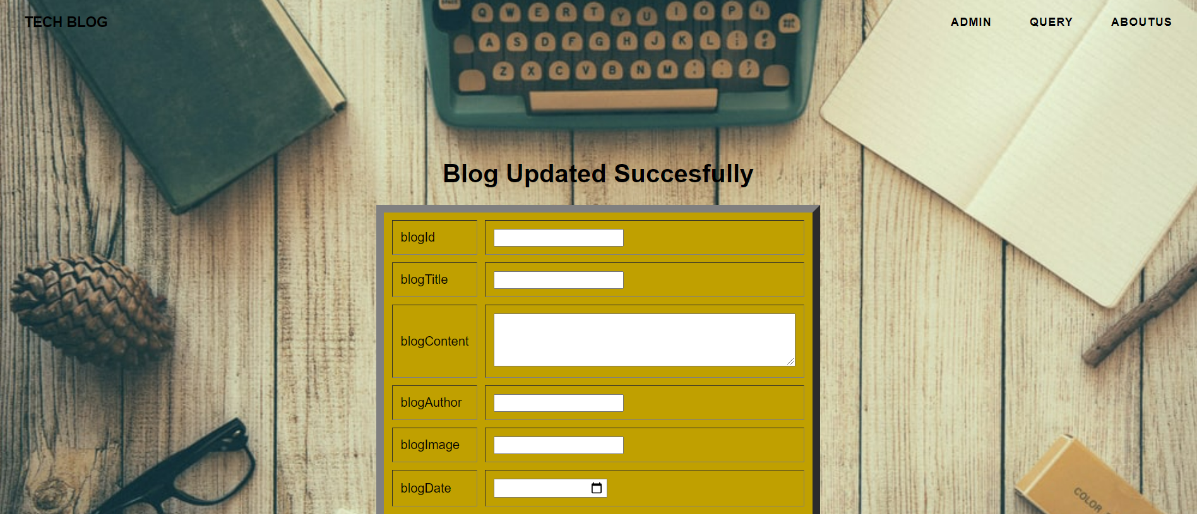

|  |  |
| --- | --- |
| Brief Description | **Enquiry Form** |
| Basic Flow | 1.This case describes how a user can raise a enquiry / request.  2.Open the enquiry page  3.Enter the information   * Name * Mobile no. * Email * Query |
| Alternate Flow | The system will validate the information provided. If any invalid data is found, the input form will be redirected with error message. |
| Validation | All the Fields are required. |
| Pre-Conditions | User should have network access and Browser with latest updates. |
| Post-Conditions | Success message should be shown. |

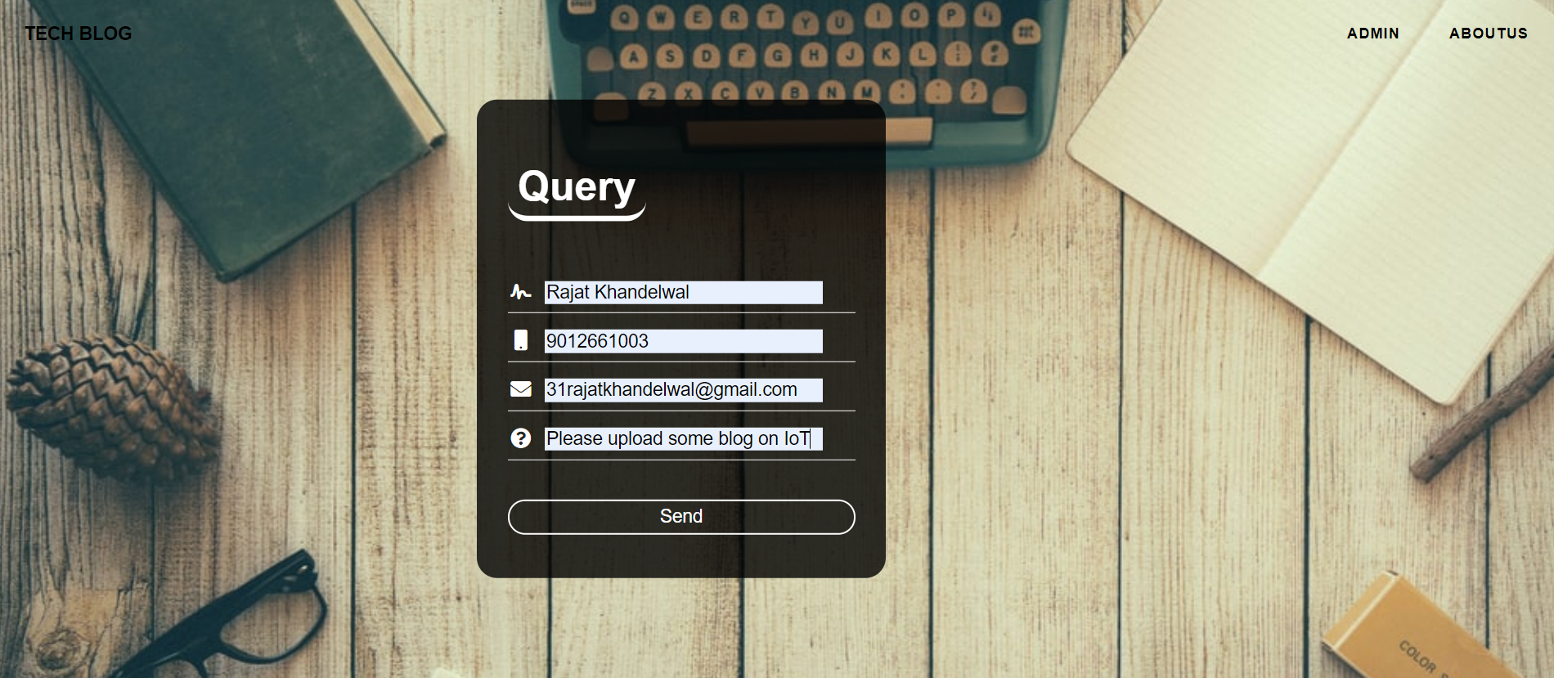

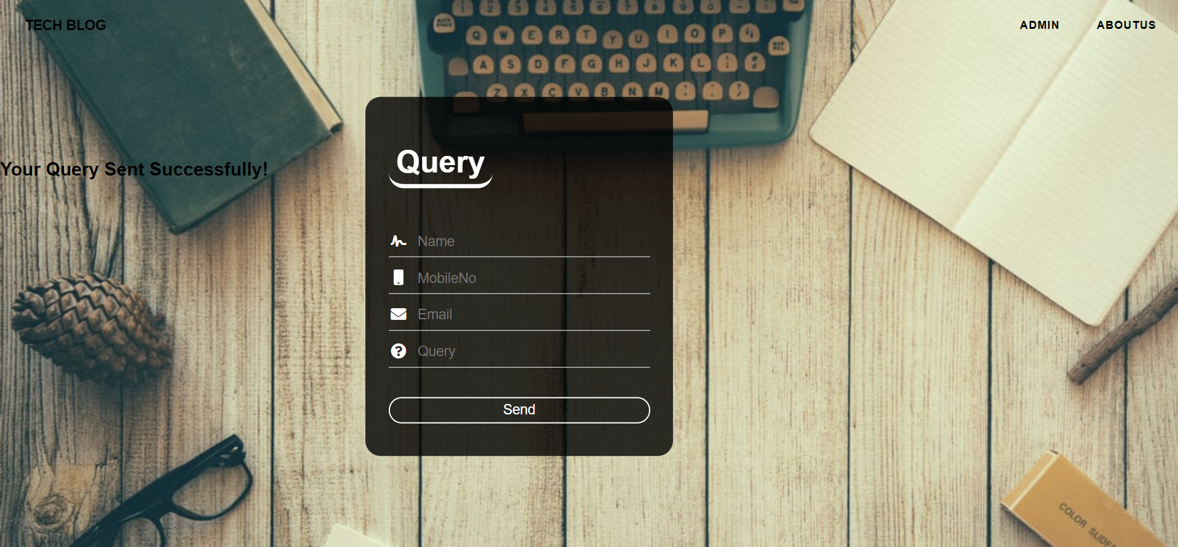

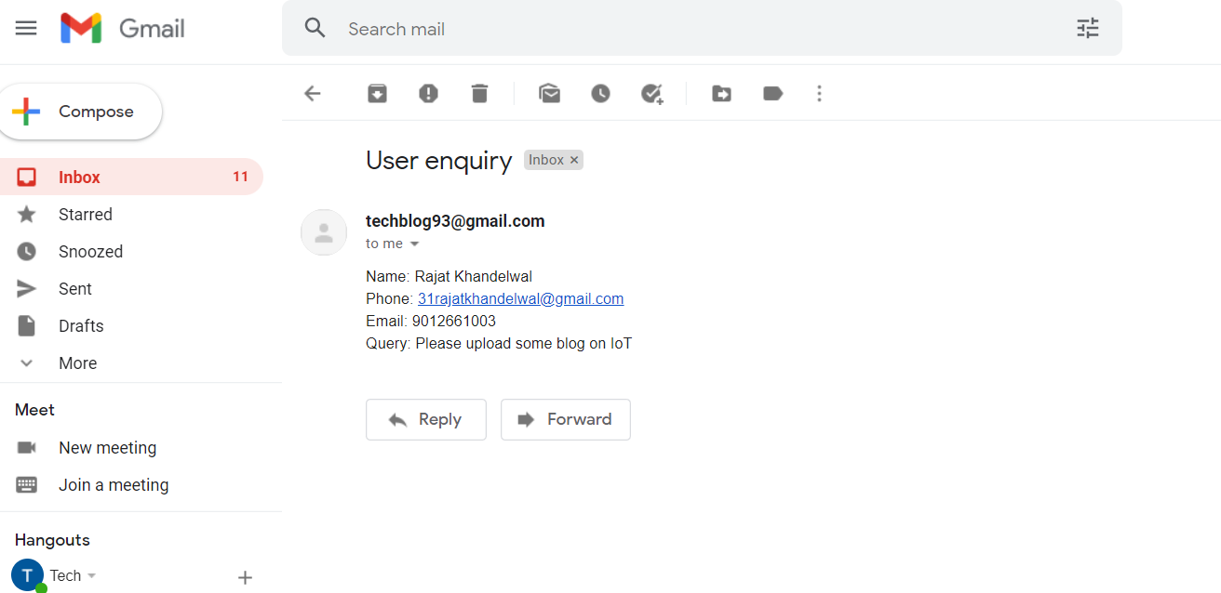

**Bibliography**

* Google for problem solving
* Youtube – For Email API
* www.javatpoint.com

**Conclusion**

While developing the system a conclusion effort has been made to create and develop a software package, making use of available tools, techniques and resources that would generate a proper system for cases.

While making the system, an eye has been kept on making it user friendly.

As such one may hope that system will be acceptable to any user and will adequately meet his/her needs. As in case of any system development process where there are a number of short comings, there have been some shortcomings in the developments of this system also.